**Tutorial documentation**

1. **Hardware preparation**

STM32F103RCT6, 12 V power supply, TB6612FNG motor drive module, 2 DC gearmotors, DuPont line (several).

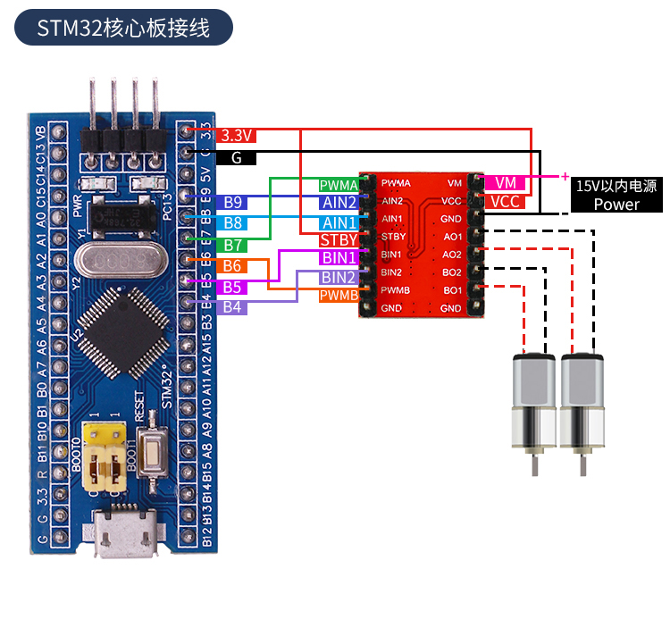

Note: The hardware wiring diagram shows the STM32F103C8T6 wiring diagram, STM32F103RCT6 all wiring is the same, according to the corresponding pin connection.

1. **Purpose of the experiment**

After the STM32 MCU is powered on, the experimental effect cart advances 1s and stops 1s.

**3、Main code**

**Motor PWM initialization**

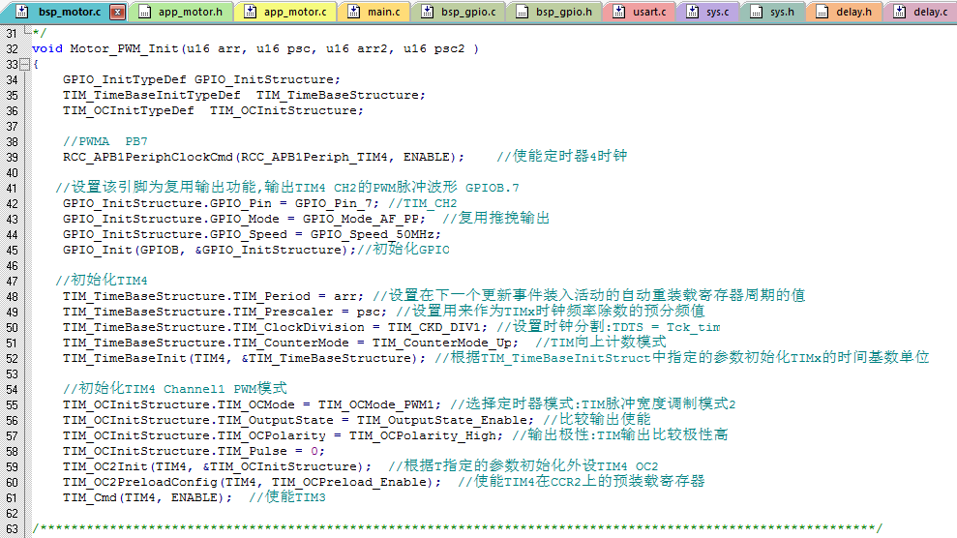

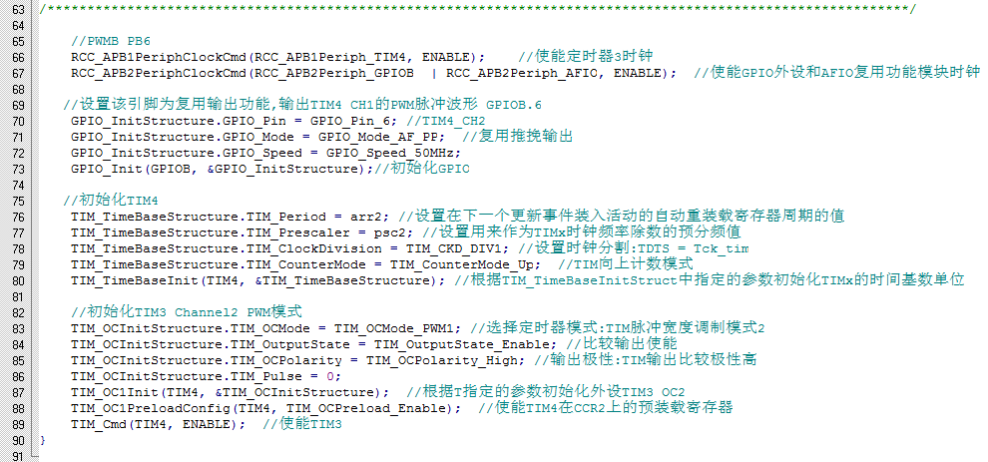

**Motor GPIO initialization**

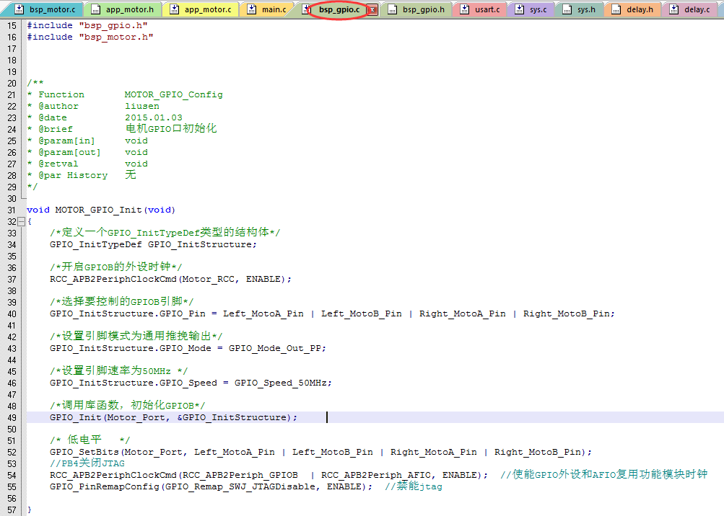

**Trolley motion function**

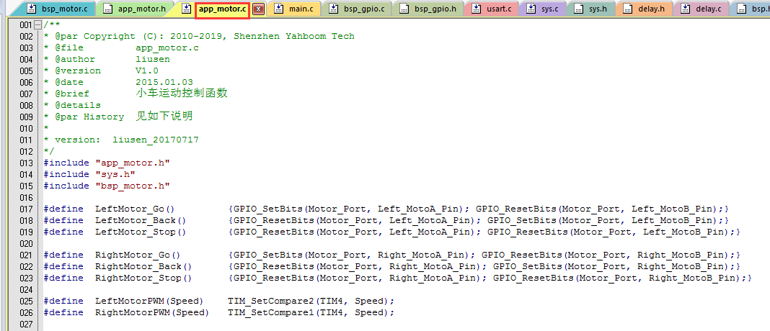

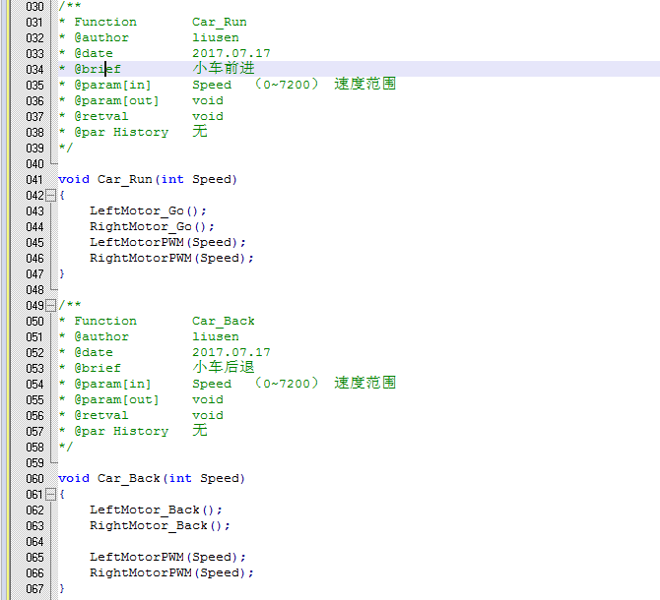

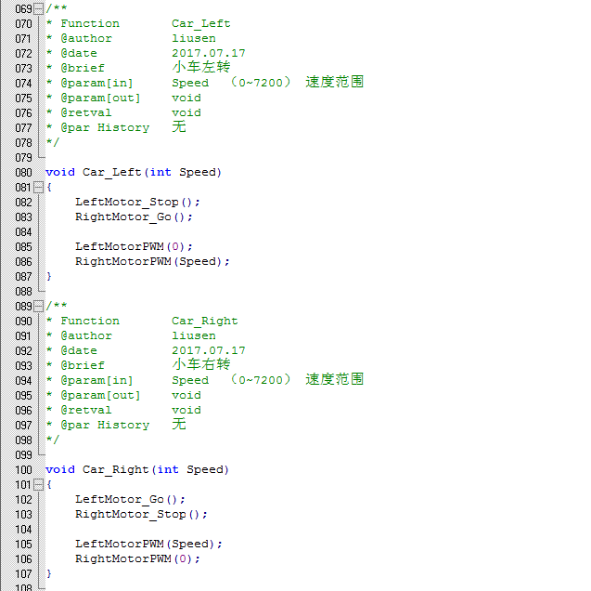

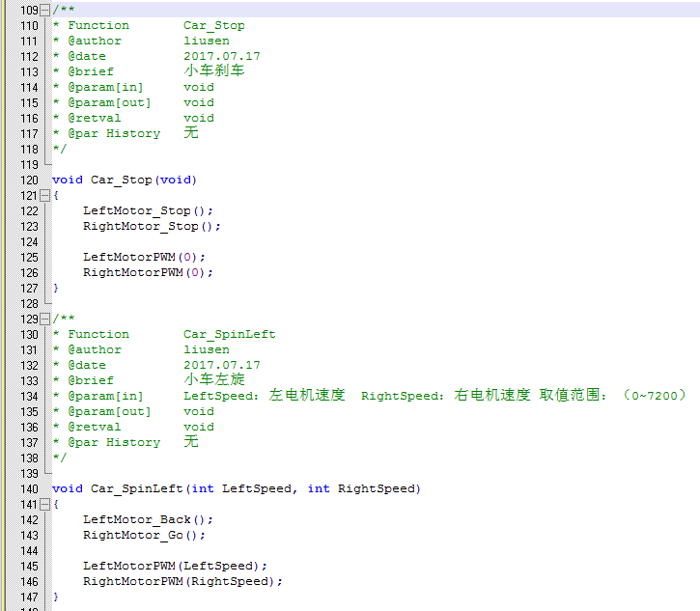

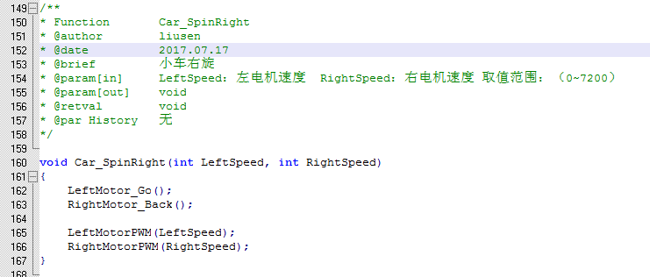

**Initialization function**

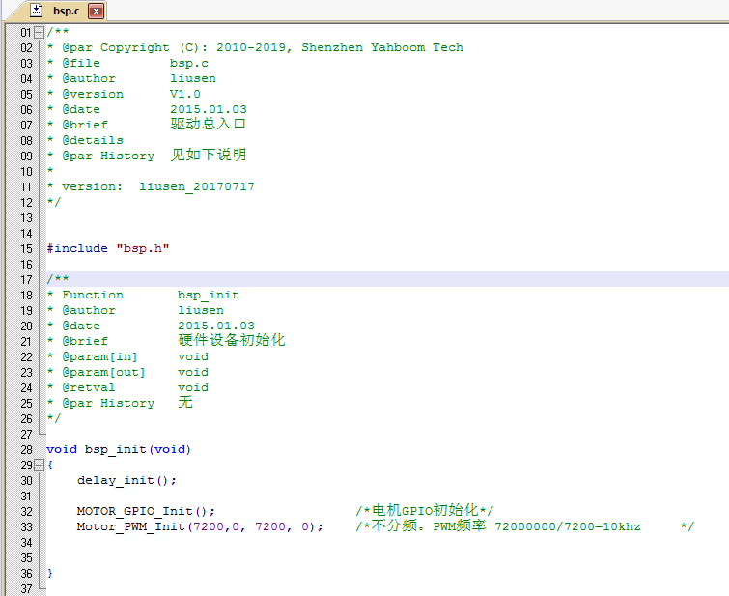

**Main function**

